OPS102 – Week 4 – File Systems - Sample Lab

### Student Name: Luca Novello - gnovello

Student ID: 038515003

**ALL ANSWERS ARE HIGHLIGHTED**

Activity 1: Redirection and Piping

Put following text to a file called gpt.txt

ChatGPT is an artificial intelligence chatbot developed by OpenAI and released in November 2022.

The name "ChatGPT" combines "Chat", referring to its chatbot functionality, and "GPT", which stands for Generative Pre-trained Transformer, a type of large language model.

Wikipedia

ChatGPT has been trained on huge amount of data scraped from internet.

This has enabled us to develp artificial programes that can answer questions like humans.

**Redirection:**

Redirection can send input to a command from a file or can send output of a command to a file.

Input redirection symbol: <

**Command < filename**

1. Run the command on Linux: **cat < gpt.txt**

What do you see and why?

### **Output:**

### ChatGPT is an artificial intelligence chatbot developed by OpenAI and released in November 2022.

### The name "ChatGPT" combines "Chat", referring to its chatbot functionality, and "GPT", which stands for Generative Pre-trained Transformer, a type of large language model.

### Wikipedia

### ChatGPT has been trained on huge amount of data scraped from internet.

### This has enabled us to develp artificial programes that can answer questions like humans.

### The command displays the contents of the gpt.txt file.

### 

1. Run similar command on Windows: **TYPE < gpt.txt**

What do you see and why?

### **Output:**

### The syntax of the command is incorrect.

### This is because Windows uses a different syntax than Linux for certain commands.

Output redirection symbol: >

**Command > filename**

1. Run the command on Linux **ls -l > list.txt**

What is the output? Explain

### **Output:**

### No output.

### 

### This command writes the output of ls -l (long list format of the contents of the current directory) into a file named list.txt, or it will create a new file and save it as list.txt.

1. Run equivalent command on Windows: **dir > list.txt**

What is the output? Explain

### **Output:**

### No output.

### 

### This command writes the output of dir (list the contents of the current directory) into a file named list.txt, or it will create a new file and save it as list.txt to the current directory. It overwrites any previous text in the file.

1. Run the command on both Linux and Windows: **sort < list.txt**

What is the output?

### **Linux Output:**

### gpt.txt list.txt notes practice

### This command outputs the text in the list.txt file in a sorted format. The current output, although already in alphabetical order, didn’t get sorted because all the text is on the same line.

### **Windows Output:**

### 2 Dir(s) 407,611,621,376 bytes free

### 2 File(s) 445 bytes

### Directory of C:\Users\l_nov\OPS102

### Volume in drive C is Windows

### Volume Serial Number is D442-CFC0

### 2024-02-08 01:47 PM <DIR> ..

### 2024-02-08 01:48 PM 445 gpt.txt

### 2024-02-08 01:50 PM 0 list.txt

### 2024-02-08 01:50 PM <DIR>

### This command outputs the text in the list.txt file in a sorted format. The current output sorts each line into alphabetical order.

**Piping:**

**Command1 | Command2**

Piping is used to redirect output of first command to the input of the second command. This allows to combine simple commands to achieve more complex task.

Perform following tasks and add screenshots

1. On Linux run the command **ls /bin | more**

What do you see and why?

### It outputs the contents of the /bin folder, and then uses the “more” format to display the contents.

1. Suppose you have a text file called gpt.txt having following text in it

On Windows run the command **TYPE gpt.txt | FIND “GPT”**

What is the output? Explain it:

### **Output:**

### ChatGPT is an artificial intelligence chatbot developed by OpenAI and released in November 2022.

### The name "ChatGPT" combines "Chat", referring to its chatbot functionality, and "GPT", which stands for Generative Pre-trained Transformer, a type of large language model.

### ChatGPT has been trained on huge amount of data scraped from internet.

### 

### The command located the contents of the gpt.txt and then output any line with “GPT” in it.

(TYPE is equivalent to cat command on Linux)

1. Run and explain the command: **cat < gpt.txt | sort > out.txt**

Explain what is happening in the above command?

### The command located the contents of the gpt.txt file, and then sorted it alphabetically, by line, created a file named “out.txt”, wrote it to a out.txt and saved it.

**Activity 2: File Permissions**

Consider following image for next tasks

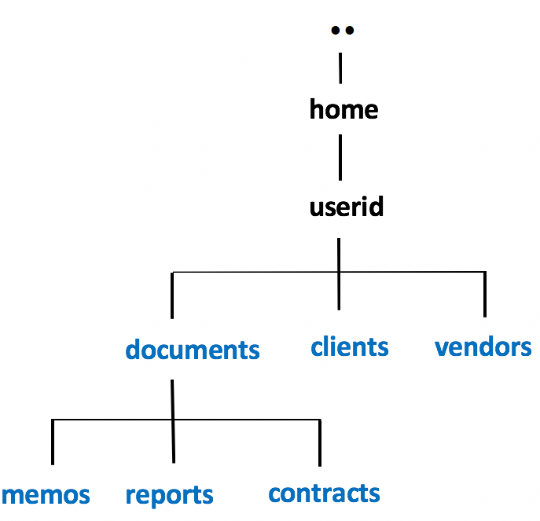

Choose any way to create following files in the respective folders

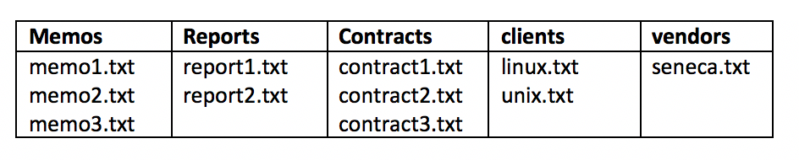

1. Issue the following Linux commands:  
   **ls -ld ~/documents ~/clients ~/vendors**

### **Output:**

### drwxr-xr-x 2 gnovello users 39 Feb 8 14:32 /home/gnovello/clients

### drwxr-xr-x 5 gnovello users 51 Feb 8 14:28 /home/gnovello/documents

### drwxr-xr-x 2 gnovello users 24 Feb 8 14:32 /home/gnovello/vendors

**ls -lR ~/documents ~/clients ~/vendors**

**Output:**

### total 0

### -rw-r--r-- 1 gnovello users 0 Feb 8 14:32 linux.txt

### -rw-r--r-- 1 gnovello users 0 Feb 8 14:32 unix.txt

### 

### /home/gnovello/documents:

### total 0

### drwxr-xr-x 2 gnovello users 69 Feb 8 14:31 contracts

### drwxr-xr-x 2 gnovello users 57 Feb 8 14:30 memos

### drwxr-xr-x 2 gnovello users 44 Feb 8 14:31 reports

### 

### /home/gnovello/documents/contracts:

### total 0

### -rw-r--r-- 1 gnovello users 0 Feb 8 14:31 contract1.txt

### -rw-r--r-- 1 gnovello users 0 Feb 8 14:31 contract2.txt

### -rw-r--r-- 1 gnovello users 0 Feb 8 14:31 contract3.txt

### 

### /home/gnovello/documents/memos:

### total 0

### -rw-r--r-- 1 gnovello users 0 Feb 8 14:29 memo1.txt

### -rw-r--r-- 1 gnovello users 0 Feb 8 14:29 memo2.txt

### -rw-r--r-- 1 gnovello users 0 Feb 8 14:29 memo3.txt

### 

### /home/gnovello/documents/reports:

### total 0

### -rw-r--r-- 1 gnovello users 0 Feb 8 14:31 report1.txt

### -rw-r--r-- 1 gnovello users 0 Feb 8 14:31 report2.txt

### 

### /home/gnovello/vendors:

### total 0

### -rw-r--r-- 1 gnovello users 0 Feb 8 14:32 seneca.txt

1. Let's limit access to the **clients** and **vendors** directories to only yourself and same group members.  
   Issue the following Linux command:  
   **chmod 750 ~/clients ~/vendors**
2. Issue the **ls -ld** and **ls -lR** commands (as you did in *step #8*) to confirm that the permissions for those directories have been changed.  
   **NOTE:** The **-R** option for the **chmod** command can change the file permissions recursively within a directory structure.

### **ls -ld Output:**

### drwx--x--x 9 gnovello users 239 Feb 8 14:35 .

### 

### **ls -lR Output:**

### Very long detailed list of all files in all directories and sub-directories.

1. Issue the following Linux command: **chmod 750 -R ~/documents**
2. Issue the **ls -ld** command to confirm the permissions for the  
   **~/documents**, **~/document/memos** , **~/documents/reports**, and **~/documents/contracts** directories.

### **Output:**

### drwxr-x--- 5 gnovello users 51 Feb 8 14:28 /home/gnovello/documents

### drwxr-x--- 2 gnovello users 57 Feb 8 14:30 /home/gnovello/documents/memos/

### drwxr-x--- 2 gnovello users 69 Feb 8 14:31 /home/gnovello/documents/contracts/

### drwxr-x--- 2 gnovello users 44 Feb 8 14:31 /home/gnovello/documents/reports/

1. Issue the following Linux command: **ls -lR ~/documents**  
   What do you noticed happened to the permissions for the regular files contained in those directories.  
   Did those regular file permissions change?

**Output:**

### /home/gnovello/documents:

### total 0

### drwxr-x--- 2 gnovello users 69 Feb 8 14:31 contracts

### drwxr-x--- 2 gnovello users 57 Feb 8 14:30 memos

### drwxr-x--- 2 gnovello users 44 Feb 8 14:31 reports

### /home/gnovello/documents/contracts:

### total 0

### -rwxr-x--- 1 gnovello users 0 Feb 8 14:31 contract1.txt

### -rwxr-x--- 1 gnovello users 0 Feb 8 14:31 contract2.txt

### -rwxr-x--- 1 gnovello users 0 Feb 8 14:31 contract3.txt

### /home/gnovello/documents/memos:

### total 0

### -rwxr-x--- 1 gnovello users 0 Feb 8 14:29 memo1.txt

### -rwxr-x--- 1 gnovello users 0 Feb 8 14:29 memo2.txt

### -rwxr-x--- 1 gnovello users 0 Feb 8 14:29 memo3.txt

### /home/gnovello/documents/reports:

### total 0

### -rwxr-x--- 1 gnovello users 0 Feb 8 14:31 report1.txt

### -rwxr-x--- 1 gnovello users 0 Feb 8 14:31 report2.txt

### The files permissions were changed to the same permissions that the parent directory was changed to.

We will now change permissions for regular text file contained in subdirectories  
 of the **documents** directory to: **r w - r - - - - -**

1. Issue the following Linux commands:   
   **chmod 640 ~/documents/memos/memo*.txt  
   chmod 640 ~/documents/reports/report*.txt  
   chmod 640 ~/documents/contracts/contract*.txt**
2. Issue the **ls -lR** command for the **~/documents** directory to confirm that those regular file permissions have changed.

**Output:**

### /home/gnovello/documents/:

### total 0

### drwxr-x--- 2 gnovello users 69 Feb 8 14:31 contracts

### drwxr-x--- 2 gnovello users 57 Feb 8 14:30 memos

### drwxr-x--- 2 gnovello users 44 Feb 8 14:31 reports

### 

### /home/gnovello/documents/contracts:

### total 0

### -rw-r----- 1 gnovello users 0 Feb 8 14:31 contract1.txt

### -rw-r----- 1 gnovello users 0 Feb 8 14:31 contract2.txt

### -rw-r----- 1 gnovello users 0 Feb 8 14:31 contract3.txt

### 

### /home/gnovello/documents/memos:

### total 0

### -rw-r----- 1 gnovello users 0 Feb 8 14:29 memo1.txt

### -rw-r----- 1 gnovello users 0 Feb 8 14:29 memo2.txt

### -rw-r----- 1 gnovello users 0 Feb 8 14:29 memo3.txt

### 

### /home/gnovello/documents/reports:

### total 0

### -rw-r----- 1 gnovello users 0 Feb 8 14:31 report1.txt

### -rw-r----- 1 gnovello users 0 Feb 8 14:31 report2.txt

1. Issue the following Linux command to add write permissions for all files in the memos directory  
   for yourself (i.e. user): **chmod u+w ~/documents/memos/\***

**Output:**

### /home/gnovello/documents/memos/:

### total 0

### -rw-r----- 1 gnovello users 0 Feb 8 14:29 memo1.txt

### -rw-r----- 1 gnovello users 0 Feb 8 14:29 memo2.txt

### -rw-r----- 1 gnovello users 0 Feb 8 14:29 memo3.txt

Instructor Note: Use Windows Properties to show how to change file permissions